Project Development Phase
Model Performance Test
Date | 13 November 2022
Team ID | PNT2022TMID02425
Project Name | Web Phishing Detection
Maximum Marks | 10 Marks

Model Performance Testing:
S.No. | Parameter | Values | Screenshot
1. | Metrics | Classification Model: xgb(Gradient Boost classification)  Accuracy Score-99.5% | 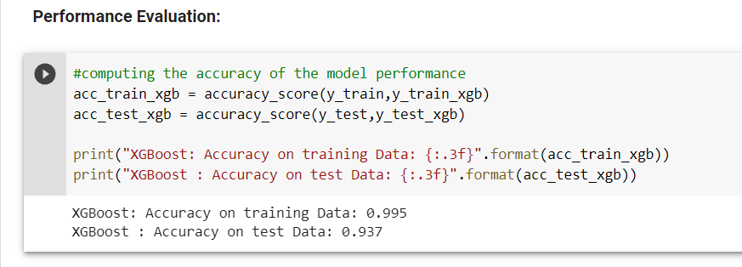
2. | Tune the Model | Hyper Parameter Tuning – 99%  Validation Method -KFOLD & Cross Validation Method | 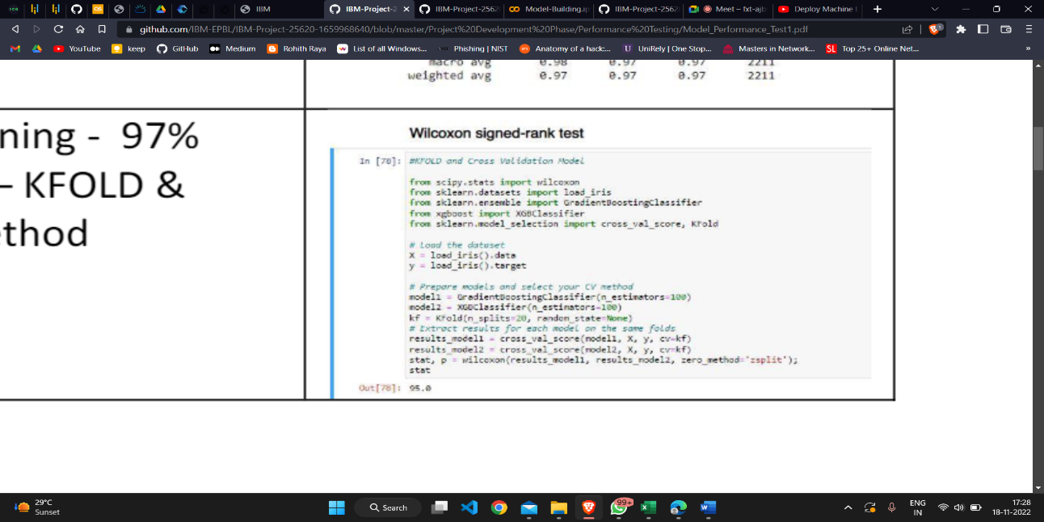

- METRICS:
CLASSIFICATION REPORT:



- PERFROMANCE & FEATURE ACCURACY:

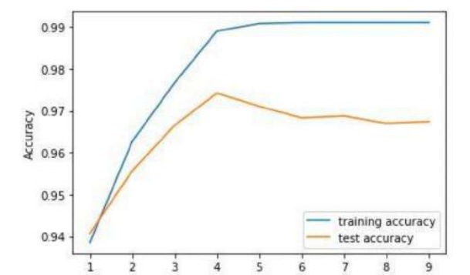

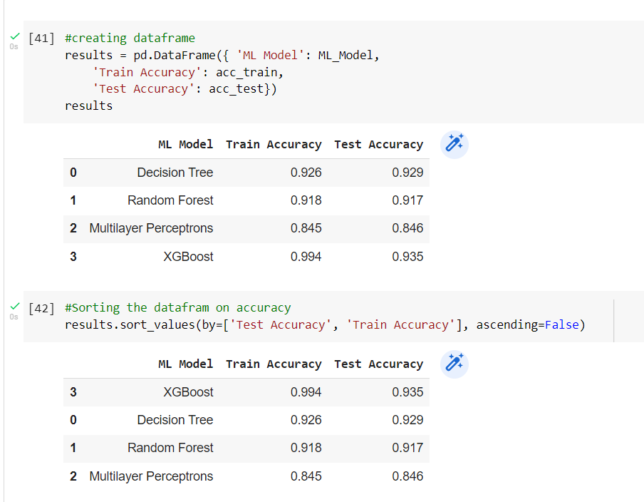

FEATURES:
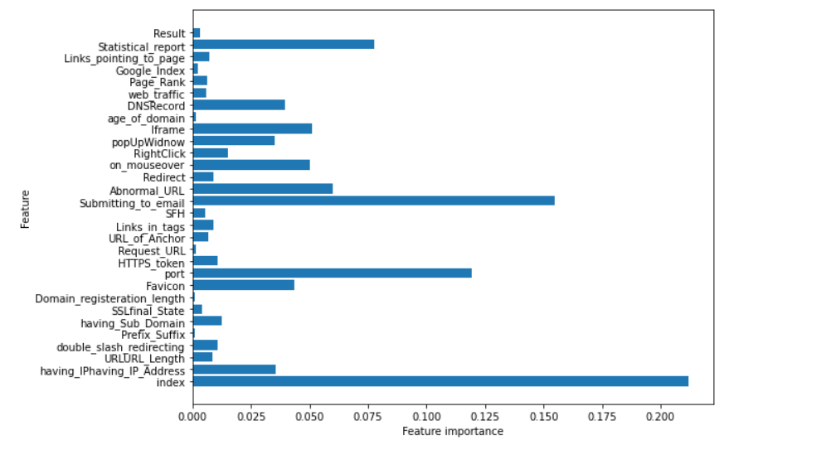

- TUNE THE MODEL: HYPER-PARAMETER TUNING.

